**Building a 99% Confidence Interval Using Sample Standard Deviation**

**Objective: Use the sample standard deviation and the t-distribution to calculate the 99% confidence interval for the mean number of characters printed before failure.**

Provides functions for statistical operations, such as critical values from the t-distribution.

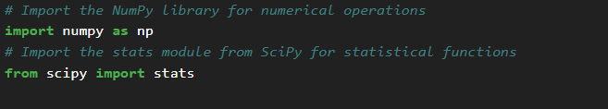

**Load the data**



contains the recorded durability of 15 print-heads in millions of characters

**Calculate Sample Statistics**

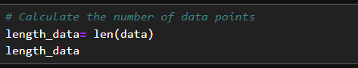

Calculate the sample size (the number of data points).

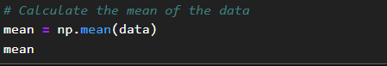

Compute the average (mean) of the sample data using np.mean



calculates the sample standard deviation. ddof=1 is used for the sample standard deviation formula.

**Degrees of Freedom**

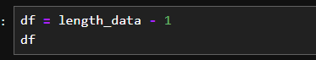

(degrees of freedom) is used for determining the critical value from the t-distribution.

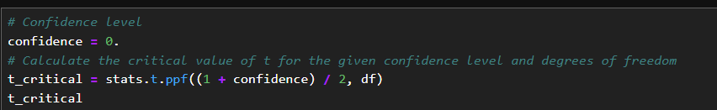**Confidence Level and Critical Value for t-Distribution**

confidence is set to 0, which is likely a mistake if you intend to compute a confidence interval. For example, for a 99% confidence level, this value should be 0.99. alculates the critical value of t for the specified confidence level and degrees of freedom. The ppf function is the percent-point function (inverse of CDF) of the t-distribution.

**Calculate Margin of Error**

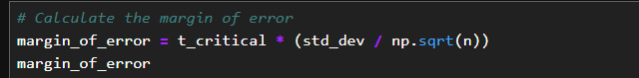

the product of the critical value and the standard error (standard deviation divided by the square root of the sample size). Note that n should be replaced by length_data.

**Compute Confidence Interval**

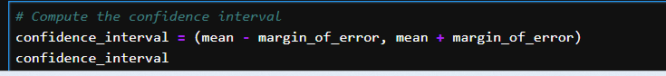

computes the range around the mean within which the true mean is expected to lie with the given confidence level

**Print Results:**

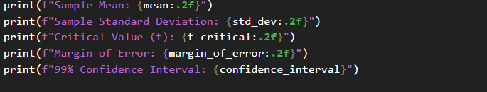

Print statements display the sample mean, standard deviation, critical value, margin of error, and the confidence interval.

**Build 99% Confidence Interval Using Known Population Standard Deviation**

If it were known that the population standard deviation is 0.2 million characters, construct a 99% confidence interval for the mean number of characters printed before failure.



This section calculates a confidence interval using the known population standard deviation. The confidence level is correctly set to 0.99.

**Calculate Critical z-Value**

calculates the critical z-value for the specified confidence level using the standard normal distribution

**Compute Confidence Interval with Population Standard Deviation**

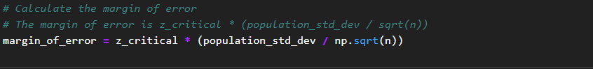

computes the range around the mean within which the true mean is expected to lie with the given confidence level.



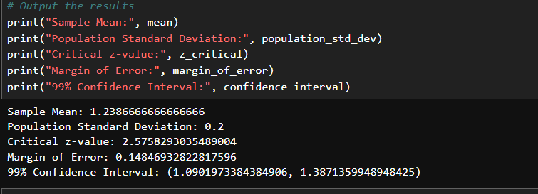

These print statements display the sample mean, known population standard deviation, critical z-value, margin of error, and confidence interval using the known population standard deviation.

**Confidence Level**: The confidence level should be set to 0.99 (or other values depending on the confidence interval desired) instead of 0..

**Replace n with length_data**:

In margin of error calculations, replace n with length_data

